How to create an Alma Analytics report of users with a patron role and a role expiry date which will expire in the next 30 days | 

These ten steps will show how to create a simple report of users with patron role which will expire before a certain date.
For details on saving the report query and adding to a dashboard see separate document.

ONE
In Alma access the Alma Analytics via Alma Menu > General > Analytics > Design Analytics

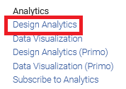

TWO
“Alma Analytics” will open in a new browser tab.
Choose “New > Analysis” and then select “Subject Area” “Users”

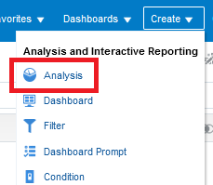

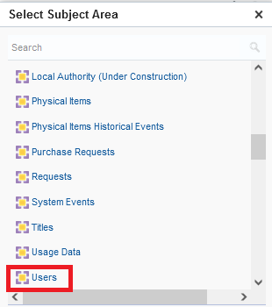

THREE
Drag in the fields you want to include in the report, for example Primary Identifier, First Name and Last Name:

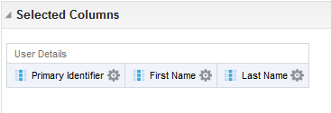

FOUR
In the lower pane “Filters” section click the “Create a filter for the current Subject Area” icon (note that there are other ways to do this as well)

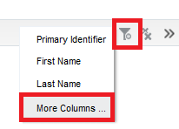

FIVE
Choose the “Role Type” from the “Role” folder and make it equal to “Patron”

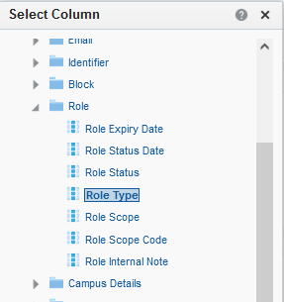

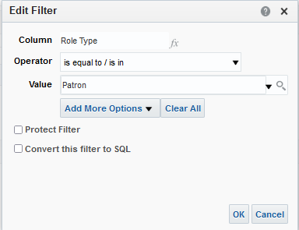

SIX
Add another filter the same way and make it for the field “Role Expiry Date” in the “Role” folder.
Make a filter and click the “Convert this filter to SQL” box

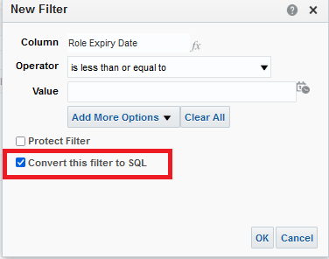

SEVEN

Make the filter be as follows. This means that the expiry date of the patron role will be between today and 30 days from now

"Role"."Role Expiry Date" between timestampadd(sql_tsi_day,+0,current_date) AND timestampadd(sql_tsi_day,+30,current_date)

See How to use the TIMESTAMPADD parameter to retrieve by today - X time in an Alma Analytics report for more information on the syntax.

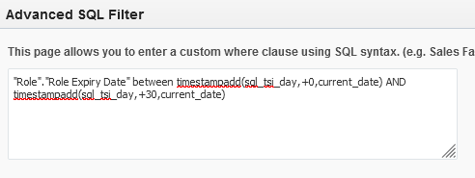

EIGHT
Here are our results

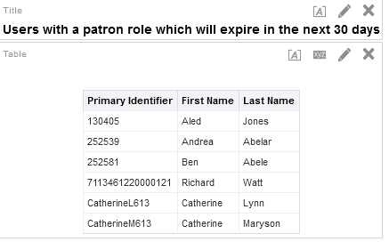

NINE

Let’s check for example the first line, Primary identifier 130405
We see that the expiration date is for August 29, 2021.
That is between today and 30 days from now.

